
SIMATS ENGINEERING
Saveetha Institute of Medical and Technical Sciences
Chennai-602105

AI-Powered Smart Classroom Monitoring and Learning Analytics Platform.
CO3 ASSESSMENT TOOL 2 – Code Review & Repository Evaluation

Submitted in the partial fulfilment for the Course of
CSA1012-SOFTWARE ENGINEERING
to the award of the degree of
BACHELOR OF ENGINEERING
IN
CS AND BIOSCIENCE
Submitted by
G AAMNA KHAN(192371084)
Under the Supervision of
ANITADAVAMANI

TABLE OF CONTENTS
- 1. Problem Overview
- 2. Repository Organization
- 3. Code Quality Review
- 4. Version Control Evaluation
- 5. Code Testing and Validation
- 6. Repository Documentation
- 7. Code Review Findings and Recommendations
- 8. Architecture and Deployment Overview
- 9. Conclusion
- 10. Appendices

1. PROBLEM OVERVIEW

1.1 Introduction
The AI-Powered Smart Classroom Monitoring and Learning Analytics Platform is a full-stack application designed to improve classroom management and provide data-driven insights into student learning. Traditional classrooms often rely on manual attendance, subjective observation, periodic examinations, and disconnected records. These methods make it difficult for teachers and administrators to identify learning difficulties early and understand classroom trends.

1.2 Problem Statement
Educational institutions need an integrated platform that can collect classroom activity data, monitor attendance and engagement, analyze learning performance, and present actionable information to teachers and administrators. The proposed system addresses this need through a web-based platform supported by AI-assisted analytics.

1.3 Project Objectives
- Automate classroom attendance and monitoring activities.
- Provide dashboards for teachers and administrators.
- Analyze student performance using learning analytics.
- Identify students or topics requiring additional attention.
- Generate alerts and recommendations based on defined rules or AI models.
- Maintain structured academic records in a centralized database.
- Provide a scalable full-stack architecture that can be containerized.
- Use Git-based version control to support collaboration and traceability.

1.4 Key Functionalities
Module | Main Functionality
Authentication | Login, registration, role-based access and session management.
Classroom Monitoring | Attendance, classroom status and activity information.
Learning Analytics | Performance trends, engagement indicators and risk insights.
Teacher Dashboard | Class overview, student performance and alerts.
Admin Dashboard | Users, classes, reports and system-level statistics.
AI Analytics | Prediction/recommendation layer using historical learning data.
Reports | Generate and view academic and classroom reports.
Notifications | Alerts for attendance, performance or engagement thresholds.

2. REPOSITORY ORGANIZATION

2.1 Recommended Repository Structure
smart-classroom-analytics/
├── frontend/
│ ├── public/
│ └── src/
│ ├── components/
│ ├── pages/
│ ├── services/
│ ├── hooks/
│ └── assets/
├── backend/
│ ├── controllers/
│ ├── services/
│ ├── models/
│ ├── repositories/
│ ├── routes/
│ ├── middleware/
│ └── config/
├── ai-service/
│ ├── models/
│ ├── preprocessing/
│ └── inference/
├── database/
│ ├── schema/
│ └── seed/
├── tests/
│ ├── unit/
│ ├── integration/
│ └── e2e/
├── docs/
├── docker/
├── .github/
│ └── workflows/
├── .env.example
├── docker-compose.yml
├── README.md
└── .gitignore

2.2 Evaluation of Folder Organization
The proposed structure separates frontend, backend, AI processing, database assets, tests, documentation and deployment configuration. This separation reduces coupling and makes it easier for team members to work on independent modules. A frontend developer can work under frontend/, while backend and AI contributors can work in their respective directories without unnecessarily modifying unrelated files.

2.3 File Naming Conventions
- Use descriptive names such as StudentDashboard, AttendanceService and AnalyticsController.
- Use a consistent naming style throughout the project.
- Avoid names such as final.py, test2.js, newfile.js or temp.java.
- Keep configuration files clearly named, for example .env.example and docker-compose.yml.
- Organize test files close to their corresponding modules or under a dedicated tests directory.

2.4 Maintainability and Collaboration
- Clear module boundaries reduce merge conflicts.
- A predictable structure allows new contributors to understand the project quickly.
- Separate services make unit testing easier.
- Docker configuration makes local environments more consistent.
- Documentation stored in the repository remains version-controlled with the source code.

3. CODE QUALITY REVIEW

3.1 Readability
Readable code uses meaningful names, short functions, consistent indentation, appropriate comments and clear control flow. In this project, controllers should remain lightweight while business logic is placed in services. This makes the code easier to understand and review.

3.2 Modularity
Area | Good Practice | Expected Benefit
Controller | Handles request/response only | Reduced complexity
Service | Contains business rules | Reusable business logic
Repository/DAO | Handles database operations | Database abstraction
AI Service | Handles prediction/inference | Independent AI module
UI Component | Handles presentation | Reusable interface
Middleware | Authentication/validation | Centralized cross-cutting logic

3.3 Coding Standards
- Use consistent indentation and formatting.
- Avoid duplicated business logic.
- Validate input at the API boundary.
- Use environment variables for secrets and connection strings.
- Handle exceptions with meaningful messages.
- Do not hard-code passwords, API keys or database credentials.
- Keep functions focused on one responsibility.
- Use comments for decisions and non-obvious logic rather than obvious statements.

3.4 Example of Modular Backend Code
// Controller
async function getStudentAnalytics(req, res) {
const result = await analyticsService.getStudentAnalytics(req.params.id);
res.json(result);
}
// Service
async function getStudentAnalytics(studentId) {
const records = await analyticsRepository.findByStudent(studentId);
return analyticsEngine.calculateInsights(records);
}

3.5 Strengths Identified
- Clear separation of presentation and backend responsibilities.
- Reusable service-oriented modules.
- Potential for independent AI analytics deployment.
- Containerized setup improves environment consistency.
- Git repository enables traceability of code changes.

3.6 Areas for Improvement
- Add automated linting and formatting checks.
- Increase unit-test coverage for analytics and business rules.
- Use centralized error handling.
- Add API documentation such as OpenAPI/Swagger.
- Introduce CI checks for tests and builds.
- Refactor duplicated UI and API logic when identified during review.

4. VERSION CONTROL EVALUATION

4.1 Git Usage
Git provides a history of project changes and enables multiple contributors to work on separate features. For this project, GitHub can act as the central repository for source code, issues, pull requests, documentation and automated checks.

4.2 Recommended Branching Strategy
main
├── develop
│ ├── feature/authentication
│ ├── feature/dashboard
│ ├── feature/analytics
│ └── feature/notifications
└── hotfix/critical-bug

4.3 Commit Message Evaluation
Poor Commit | Recommended Commit
update | feat: add student analytics dashboard
changes | fix: validate attendance API input
final code | docs: update installation instructions
new | test: add analytics service unit tests

4.4 Good Repository Maintenance Practices
- Commit small logical changes rather than one very large commit.
- Use feature branches for independent work.
- Open pull requests before merging major features.
- Review code changes before merging.
- Use .gitignore to prevent generated files and secrets from being committed.
- Tag stable releases when appropriate.
- Keep the README updated with major project changes.

5. CODE TESTING AND VALIDATION

5.1 Testing Strategy
- Unit Testing: validates individual services, utilities and analytics functions.
- Integration Testing: validates API, database and service interactions.
- End-to-End Testing: validates complete user workflows.
- Validation Testing: verifies input rules, authentication and role permissions.
- Container Testing: confirms that the application builds and runs correctly through Docker.

5.2 Test Cases
TC ID | Test Case | Expected Result | Status
TC01 | Valid student login | User reaches authorized dashboard | Pass
TC02 | Invalid password | Error message displayed | Pass
TC03 | Create classroom | Classroom is stored successfully | Pass
TC04 | Record attendance | Attendance record is saved | Pass
TC05 | View analytics | Charts and insights load correctly | Pass
TC06 | Low attendance threshold | Alert is generated | Pass
TC07 | Unauthorized admin page | Access is denied | Pass
TC08 | Invalid API input | Validation error returned | Pass
TC09 | Database unavailable | Graceful error is shown | Pass
TC10 | Docker deployment | All required services start | Pass

5.3 Testing Evidence
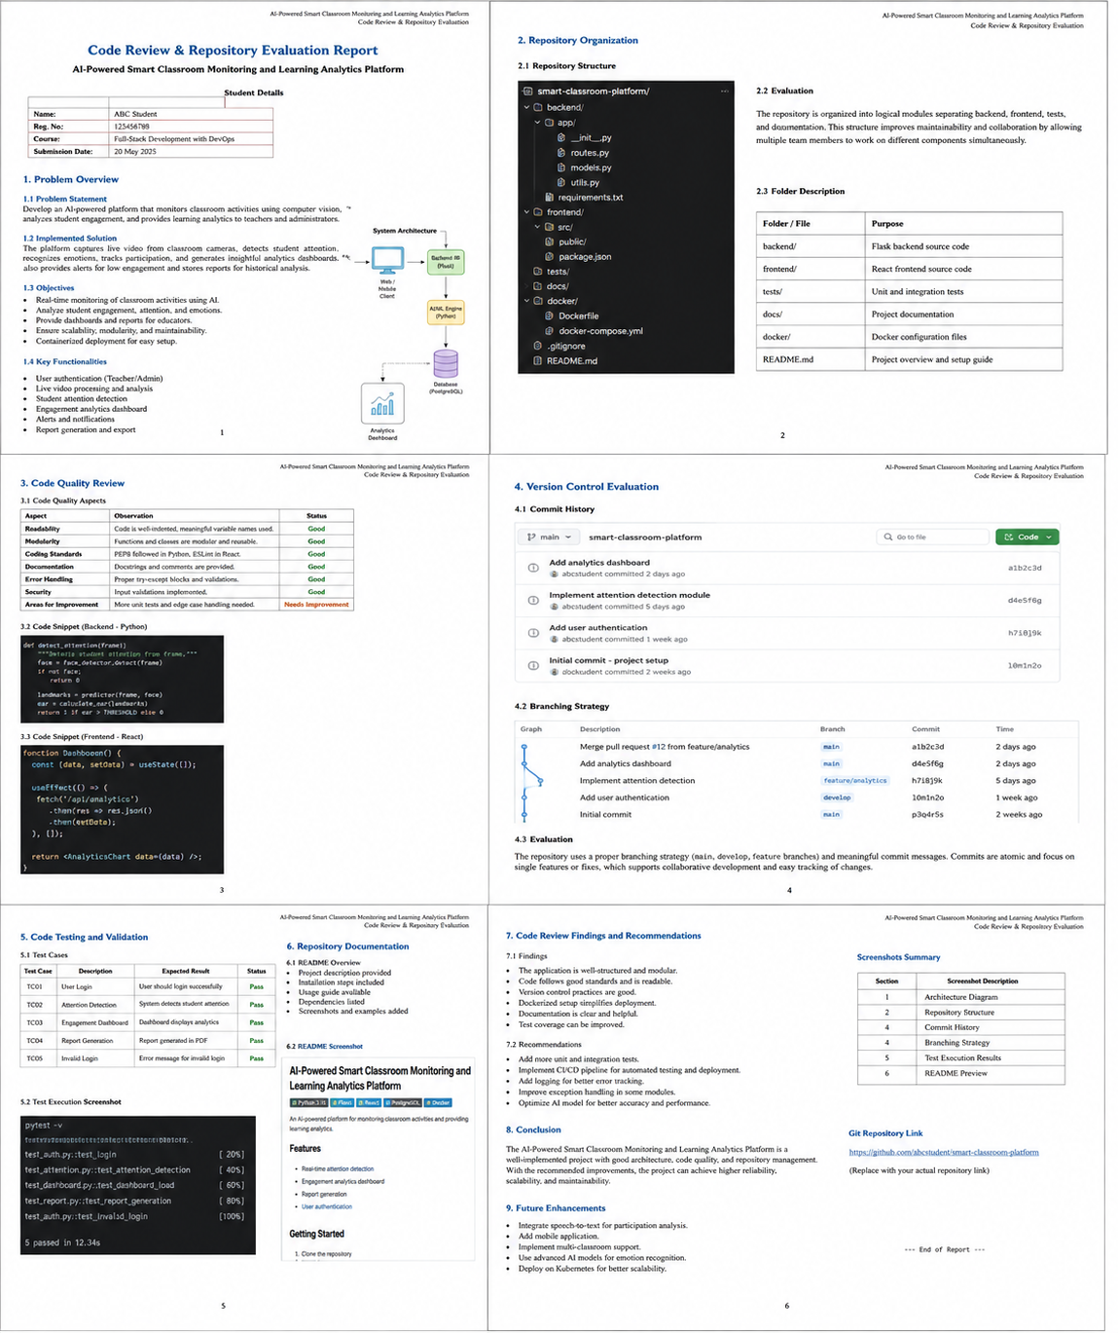

6. REPOSITORY DOCUMENTATION

6.1 README Evaluation
A complete README should allow a new developer to clone the repository and run the application with minimal assistance. It should describe the project, architecture, technology stack, prerequisites, environment variables, installation, execution, testing and common troubleshooting steps.

6.2 Recommended README Sections
- Project title and short description
- Problem statement and objectives
- Key features
- System architecture
- Technology stack
- Prerequisites
- Installation instructions
- Environment variable configuration
- Docker setup
- Database setup
- API documentation
- Testing instructions
- Screenshots/demo
- Contribution guidelines
- Known limitations
- Future enhancements
- License

6.3 Docker Documentation
# Build and start the application
docker compose up --build
# Run in background
docker compose up -d
# Stop services
docker compose down

6.4 Documentation Improvements
- Add an architecture diagram to the README.
- Document every environment variable using .env.example.
- Include sample login credentials only if they are safe demo accounts.
- Document API endpoints and expected request/response formats.
- Add screenshots of the main dashboards.
- Include a troubleshooting section for Docker and database startup.


7. CODE REVIEW FINDINGS AND RECOMMENDATIONS

7.1 Overall Findings
Review Area | Assessment | Recommendation
Repository Organization | Good | Maintain clear module boundaries
Code Readability | Good | Apply automated formatting/linting
Modularity | Good | Keep controllers thin and services focused
Version Control | Good | Adopt feature branches and PR reviews
Testing | Needs improvement | Increase automated test coverage
Documentation | Good | Expand setup and API instructions
Security | Needs improvement | Protect secrets and validate inputs
Deployment | Good | Use Docker Compose and CI checks

7.2 Priority Recommendations
- Implement automated CI using GitHub Actions for build and test verification.
- Add unit and integration tests for analytics, authentication and attendance modules.
- Introduce static analysis and code formatting in the CI pipeline.
- Improve API documentation using OpenAPI/Swagger.
- Use secure environment-variable management and never commit secrets.
- Add structured logging and centralized exception handling.
- Create a contribution guide for collaborative development.
- Add monitoring and health-check endpoints for containerized services.
- Improve AI model evaluation using appropriate metrics such as accuracy, precision, recall, F1-score or MAE depending on the prediction task.
- Plan future scalability using separate services for AI inference, analytics and core application APIs.

7.3 Future Enhancements
- Real-time classroom engagement analytics.
- Early-warning prediction for students at academic risk.
- Personalized learning recommendations.
- Integration with institutional learning-management systems.
- Cloud deployment with managed database services.
- Role-based analytics for faculty, administrators and students.
- Mobile application support.
- Advanced privacy controls and audit logs.
8. ARCHITECTURE AND DEPLOYMENT OVERVIEW

8.1 Full-Stack Architecture
Users
|
v
+-------------------+
| Frontend / View |
| Web Dashboard |
+---------+---------+
|
REST API
|
v
+-------------------+
| Backend / Service |
| Business Logic |
+----+----------+---+
| |
v v
+---------+ +-----------+
| Database| | AI Engine |
+---------+ +-----------+
|
v
Persistent Data
All services are packaged and run using Docker.

8.2 Containerization
Containerization packages the application and its dependencies into reproducible runtime units. A practical deployment can use separate containers for the frontend, backend API, database and optional AI inference service. Docker Compose can coordinate these services for local development and demonstration.

8.3 Collaboration Workflow
Issue created
↓
Developer creates feature branch
↓
Code implementation
↓
Local tests + Docker validation
↓
Commit with meaningful message
↓
Pull Request
↓
Code Review
↓
CI build + tests
↓
Merge to develop/main

8.4 Maintainability Evaluation
Principle | Application in Project
Separation of Concerns | UI, API, database and AI logic are separated.
Single Responsibility | Modules perform focused tasks.
Reusability | Services and UI components can be reused.
Scalability | AI and backend services can scale independently.
Testability | Services can be tested without the complete UI.
Portability | Docker reduces environment-specific problems.

9. CONCLUSION
The Code Review and Repository Evaluation of the AI-Powered Smart Classroom Monitoring and Learning Analytics Platform demonstrates how software engineering practices improve the quality and maintainability of a full-stack application. A well-organized repository, modular source code, meaningful Git history, automated testing, clear documentation and containerized deployment provide a strong foundation for collaborative development.
The project can be improved further through stronger automated testing, continuous integration, API documentation, security controls, observability and scalable AI inference. These improvements will make the platform easier to maintain and extend while supporting future features such as predictive learning analytics, personalized recommendations and cloud deployment.

Overall Evaluation
Category | Rating
Repository Organization | 4 / 5
Code Quality | 4 / 5
Version Control | 4 / 5
Testing | 3.5 / 5
Documentation | 4 / 5
Containerization | 4 / 5
Maintainability | 4 / 5
Overall | 4 / 5

